CREATE TABLE CUSTOMER_EXP08_CSA_41 (

CUSTOMERID NUMBER PRIMARY KEY,

CUSTOMERNAME VARCHAR2(100),

CONTACTNO VARCHAR2(15),

ADDRESS VARCHAR2(255),

CITY VARCHAR2(100),

POSTALCODE VARCHAR2(10),

COUNTRY VARCHAR2(100)

);

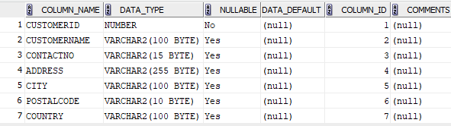

CREATE TABLE EMPLOYEES_EXP08_CSA_41 (

EMPLOYEEID NUMBER PRIMARY KEY,

LASTNAME VARCHAR2(100),

FIRSTNAME VARCHAR2(100),

BIRTHDATE DATE,

PHOTO BLOB

);

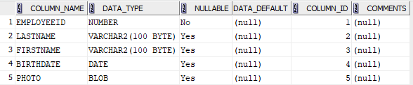

CREATE TABLE ORDERS_EXP08_CSA_41 (

ORDERID NUMBER PRIMARY KEY,

CUSTOMERID NUMBER,

EMPLOYEEID NUMBER,

ORDERDATE DATE,

SHIPPERID NUMBER,

FOREIGN KEY (CUSTOMERID) REFERENCES CUSTOMER_EXP08_CSA_41 (CUSTOMERID),

FOREIGN KEY (EMPLOYEEID) REFERENCES EMPLOYEES_EXP08_CSA_41 (EMPLOYEEID)

);

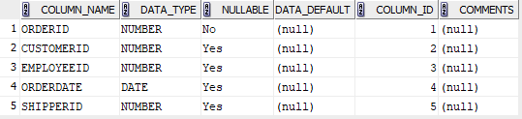

INSERT INTO CUSTOMER_EXP08_CSA_41 VALUES (1, 'ALICE SMITH', '1234567890', '123 ELM ST', 'NEW YORK', '10001', 'USA');

INSERT INTO CUSTOMER_EXP08_CSA_41 VALUES (2, 'BOB JOHNSON', '0987654321', '456 OAK ST', 'LOS ANGELES', '90001', 'USA');

INSERT INTO CUSTOMER_EXP08_CSA_41 VALUES (3, 'CHARLIE BROWN', '2345678901', '789 PINE ST', 'CHICAGO', '60601', 'USA');

INSERT INTO CUSTOMER_EXP08_CSA_41 VALUES (4, 'DIANA PRINCE', '3456789012', '321 MAPLE ST', 'SEATTLE', '98101', 'USA');

INSERT INTO CUSTOMER_EXP08_CSA_41 VALUES (5, 'EVE ADAMS', '4567890123', '654 CEDAR ST', 'HOUSTON', '77001', 'USA');

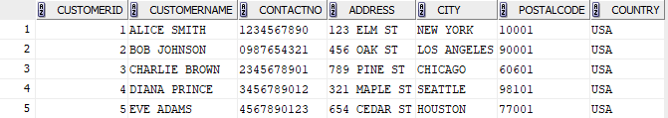

INSERT INTO EMPLOYEES_EXP08_CSA_41 VALUES (1, 'TAYLOR', 'JOHN', TO_DATE('1985-03-15', 'YYYY-MM-DD'), NULL);

INSERT INTO EMPLOYEES_EXP08_CSA_41 VALUES (2, 'WILLIAMS', 'EMMA', TO_DATE('1992-07-22', 'YYYY-MM-DD'), NULL);

INSERT INTO EMPLOYEES_EXP08_CSA_41 VALUES (3, 'JONES', 'OLIVER', TO_DATE('1975-12-11', 'YYYY-MM-DD'), NULL);

INSERT INTO EMPLOYEES_EXP08_CSA_41 VALUES (4, 'BROWN', 'AVA', TO_DATE('1980-05-30', 'YYYY-MM-DD'), NULL);

INSERT INTO EMPLOYEES_EXP08_CSA_41 VALUES (5, 'DAVIS', 'SOPHIA', TO_DATE('1988-09-09', 'YYYY-MM-DD'), NULL);

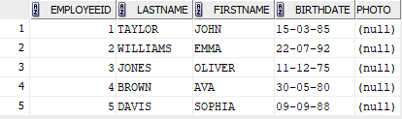

INSERT INTO ORDERS_EXP08_CSA_41 VALUES (1, 1, 1, TO_DATE('2022-01-10', 'YYYY-MM-DD'), 1);

INSERT INTO ORDERS_EXP08_CSA_41 VALUES (2, 2, 1, TO_DATE('2023-03-15', 'YYYY-MM-DD'), 2);

INSERT INTO ORDERS_EXP08_CSA_41 VALUES (3, 3, 2, TO_DATE('2021-11-20', 'YYYY-MM-DD'), 3);

INSERT INTO ORDERS_EXP08_CSA_41 VALUES (4, 1, 3, TO_DATE('2022-06-30', 'YYYY-MM-DD'), 1);

INSERT INTO ORDERS_EXP08_CSA_41 VALUES (5, 4, 2, TO_DATE('2022-02-05', 'YYYY-MM-DD'), 3);

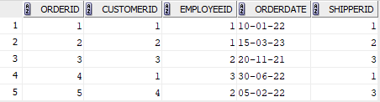

SELECT * FROM CUSTOMER_EXP08_CSA_41 ORDER BY CUSTOMERNAME ASC;

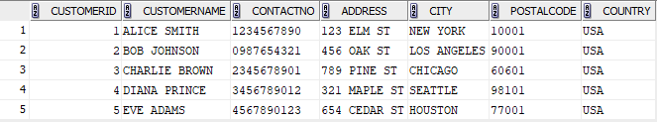

SELECT * FROM ORDERS_EXP08_CSA_41 ORDER BY ORDERDATE ASC;

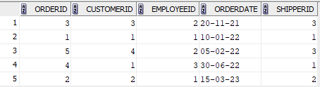

SELECT * FROM EMPLOYEES_EXP08_CSA_41 WHERE BIRTHDATE > TO_DATE('1980-01-01', 'YYYY-MM-DD') ORDER BY BIRTHDATE DESC;

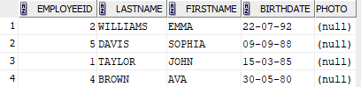

SELECT O.* FROM ORDERS_EXP08_CSA_41 O JOIN CUSTOMER_EXP08_CSA_41 C ON O.CUSTOMERID = C.CUSTOMERID WHERE C.COUNTRY = 'USA' ORDER BY O.ORDERDATE DESC;

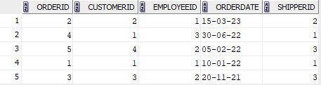

SELECT C.CUSTOMERNAME, COUNT(O.ORDERID) AS TOTALORDERS_EXP08_CSA_41 FROM CUSTOMER_EXP08_CSA_41 C LEFT JOIN ORDERS_EXP08_CSA_41 O ON C.CUSTOMERID = O.CUSTOMERID GROUP BY C.CUSTOMERNAME;

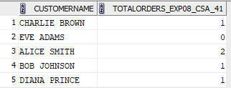

SELECT CITY, COUNT(CUSTOMERID) AS TOTALCUSTOMERS FROM CUSTOMER_EXP08_CSA_41 GROUP BY CITY;

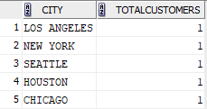

SELECT C.CUSTOMERNAME FROM CUSTOMER_EXP08_CSA_41 C JOIN ORDERS_EXP08_CSA_41 O ON C.CUSTOMERID = O.CUSTOMERID GROUP BY C.CUSTOMERNAME HAVING COUNT(O.ORDERID) > 2;



SELECT CITY FROM CUSTOMER_EXP08_CSA_41 GROUP BY CITY HAVING COUNT(CUSTOMERID) > 3;

